NEWSLETTER
WAYNE MENDENHALL
September, 2016
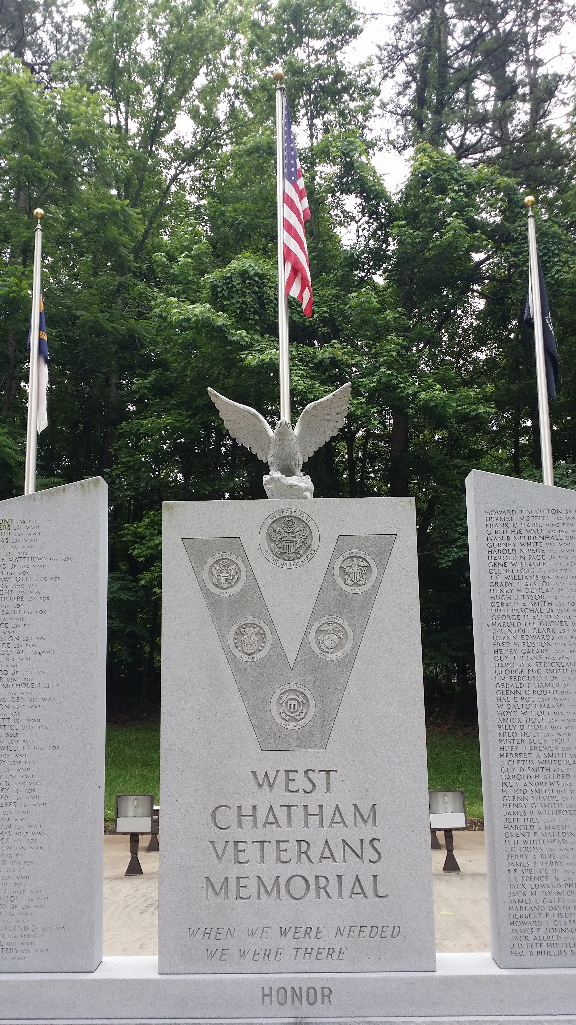

SILER CITY POST #0093
For God and Country
919-200-1809
Jeff Cathcart, Post Commander
jcathcart@freedomwon.org

Post meetings are held the 4th Tuesday of each month at 6:00 p.m.
at the Drydock Seafood Restaurant
408 N. 2nd Avenue, Siler City, NC 27344

COMMANDER’S MESSAGE:

Happy New Year! As we embark on yet another year of service to God & Country, let us remember that service never ends and freedom is not free. Although many of us are at or near the end of our tour of duty from our place of employment, retirement from our service to God & Country is not an option, nor should it be; because the freedom we enjoy was not free. It was paid for by our Lord on Calvary and by the fighting men and woman of our great nation on the battlefields of war. Although we can never repay our Lord with works of service and we cannot bring back one dead patriot by what we do for others, we must continue to fight the good fight in their stead. To God, we owe obedience to His command for us to show the love of Jesus Christ to our neighbors and share His Good News Gospel with every living creature, and to our fellow comrades in arms, we owe a debt of responsibility to preserve, protect and defend, the life, liberty, and pursuit of happiness, for which they made the ultimate sacrifice. We have much to do….

It’s alive!! Thanks to the great work of our Post Vice-Commander, Bill Haiges, our Post 93 website is up and running. Please go to www.freedomwon.org and check it out. Going forward, all routine Post 93 communications will be done via email and our website. I encourage you to check your email at least once per day for Post updates. Meeting minutes, agendas and newsletters will be sent to you via email as they are prepared. They will also be placed on our Post 93 website. If you don’t have an email account, please contact Vice-Commander Haiges at 919-704-6812 and he will provide you with a freedomwon.org email account. It’s free for you to use as long as you remain a member in good standing of Post 93. In the event of an emergency or a last-minute change in Post 93 plans, one of our Post officers will notify all Post 93 members by phone. Please be sure that we have your current contact information. If not, email your information to me at jcathcart@freedomwon.org or to Bill at bhaiges@freedomwon.org. Be sure to include an emergency contact phone number so we can notify someone on your behalf in case you become ill or are injured at one of our meetings or events.

Just one!!! - As you know, our Post 93 is about to begin revitalization efforts, which means, recruiting and fundraising will be at the top of our agenda for this year. It must be, for without membership and money, our Post 93 is virtually dead in the water, and we can’t do anything except have meetings. So, whose job is it to recruit and raise money? If you guessed all Post members, you guessed correctly. It’s not easy, so I’ve decided to offer an incentive. I will match dollar for dollar, every dollar paid in new membership dues to Post 93 in 2017. That’s right, I will write a personal check for $30 to our American Legion Post 93, every time a new member (or transferring member) pays his/her $30 dues to join our Post. The catch is, you must bring them in! How? Just ask them! If you know an active duty US military member or honorably discharged veteran who has served at least one day of service during any US war time era, they’re eligible for American Legion membership. That’s all there is to it! Basically, just put them in touch with me or any other Post 93 officer and we’re able to get them signed up, I’ll pay up! The best way is to invite them to one of our Post meetings, on the fourth Tuesday of the month. So let’s see….We have 30 active Post members. If every active member recruits just one (1) new member this year, we will double our membership to 60 – We will collect $1,800.00 in dues from the 60 members – And I will write a check for $900.00, matching the dues of new members! That’s $2,700.00 in funds raised for the year, before we even have one fundraiser!! Wow….We can do this!!! Can I count on you to recruit just one??

WHAT’S HAPPENING:

We continue to collect pop-top tabs for Ronald McDonald House Charities. The aluminum tabs will be recycled and the money received from the recycling will be donated to Ronald McDonald House. Please bring your tabs with you each time you attend a regular Post 93 meeting.

Ho, Ho, Ho – Look below - See anyone you know? Yupper, that’s Jolly Old Commander, Jeff Cathcart, doing his best Jolly Old Elf, Santa Claus, imitation, at the Siler City Country Club on December 11th. Children enjoyed brunch with Santa and received a special gift from under the tree. Jesus said “Let the little children come to me, and do not hinder them, for the Kingdom of Heaven belongs to those who are like these children.” Amen!
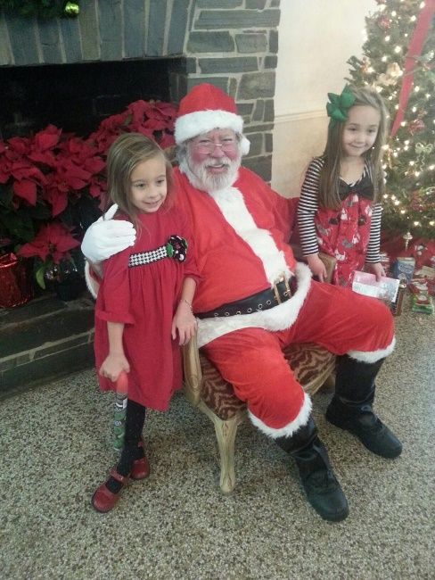

We made our annual $1000.00 donation to the Boys & Girls Club at their meeting in early December. The money we donated will go toward the $150,000.00 needed to renovate the east wing of the Wren Center, where the Boys & Girls conduct their activities. Renovations are expected to begin right away and should be completed within a year. Our Post 93 will continue to partner with the Boys & Girls Club to help raise funds to complete the project. If you’re interested in getting involved with Boys & Girls Club projects and programs, please see our Post 93, Americanism, Children & Youth Committee Chairman, Bill Milholen.

We are in the formative stages of putting together a ‘Freedom Fest’ on June 30th at the Siler City Country Club. This will be a fundraising event. We will be entertained by ‘Letters From Home’, a patriotic music, dance & comedy routine, reminiscent of the old-timey USO shows…Please mark your calendar for 7:00 p.m. – 10:00 p.m. on Friday, June 30th and stand by for details. This will be a great event!!

If you have not already done so, consider taking advantage of the Chatham County ‘Thank a Vet’ program. Just take your original (not a copy) DD-214 to the Chatham County Register of Deeds office in Pittsboro to have it scanned into their records. This is a two-fold ‘free’ benefit for you. First off, by having your original DD-214 scanned into Chatham County’s official data base of records, it becomes a permanent digital file, so that if you ever lose your original, they can produce an official ‘certified to be a true copy’ for you, for a small fee. Next, you will receive a free official government photo ID that can be used to redeem discounts from local merchants. What’s not to love? What are you waiting for??

As mentioned at our November meeting, our Post officers will conduct an audit of our Post records on January 22nd. Results of the audit will be disclosed at our next regular Post meeting on Tuesday, January 24th @ 6:00 p.m. at the Drydock Seafood Restaurant in Siler City. What’s more, at our January 24th meeting, we’ll be honoring the Siler City Police Officer of The Year as well as the Siler City Firefighter of The Year. Hope to see you there!!

